THE OPEN UNIVERSITY IN SCOTLAND
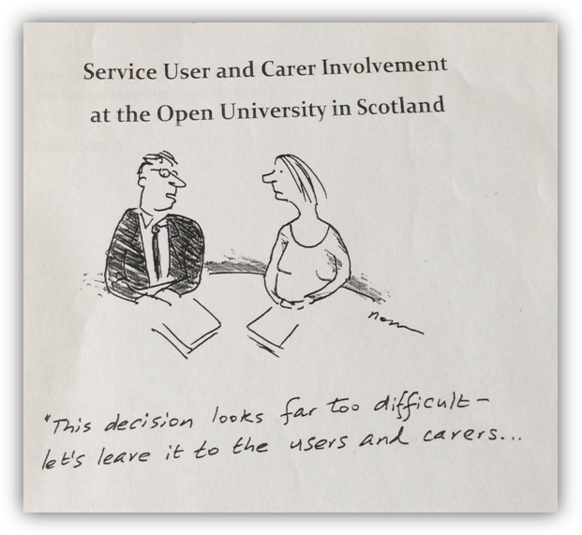
‘Creative Solutions in Challenging Times’
Report of Workshops at Keeping it Real: Service User and Carer Involvement
in Professional Education:
A National Conference
Stirling University, April 2017

Illustration: lx.iriss.org.uk
Background information to the workshops
The workshops drew upon the following sources:

Service User and Carer (SUAC) involvement in the education of health and social care workers
The involvement of service users and carers is a requirement of social work education in Scotland as it is in all four nations of the UK. It is not yet mandatory in nurse education but is recommended policy.

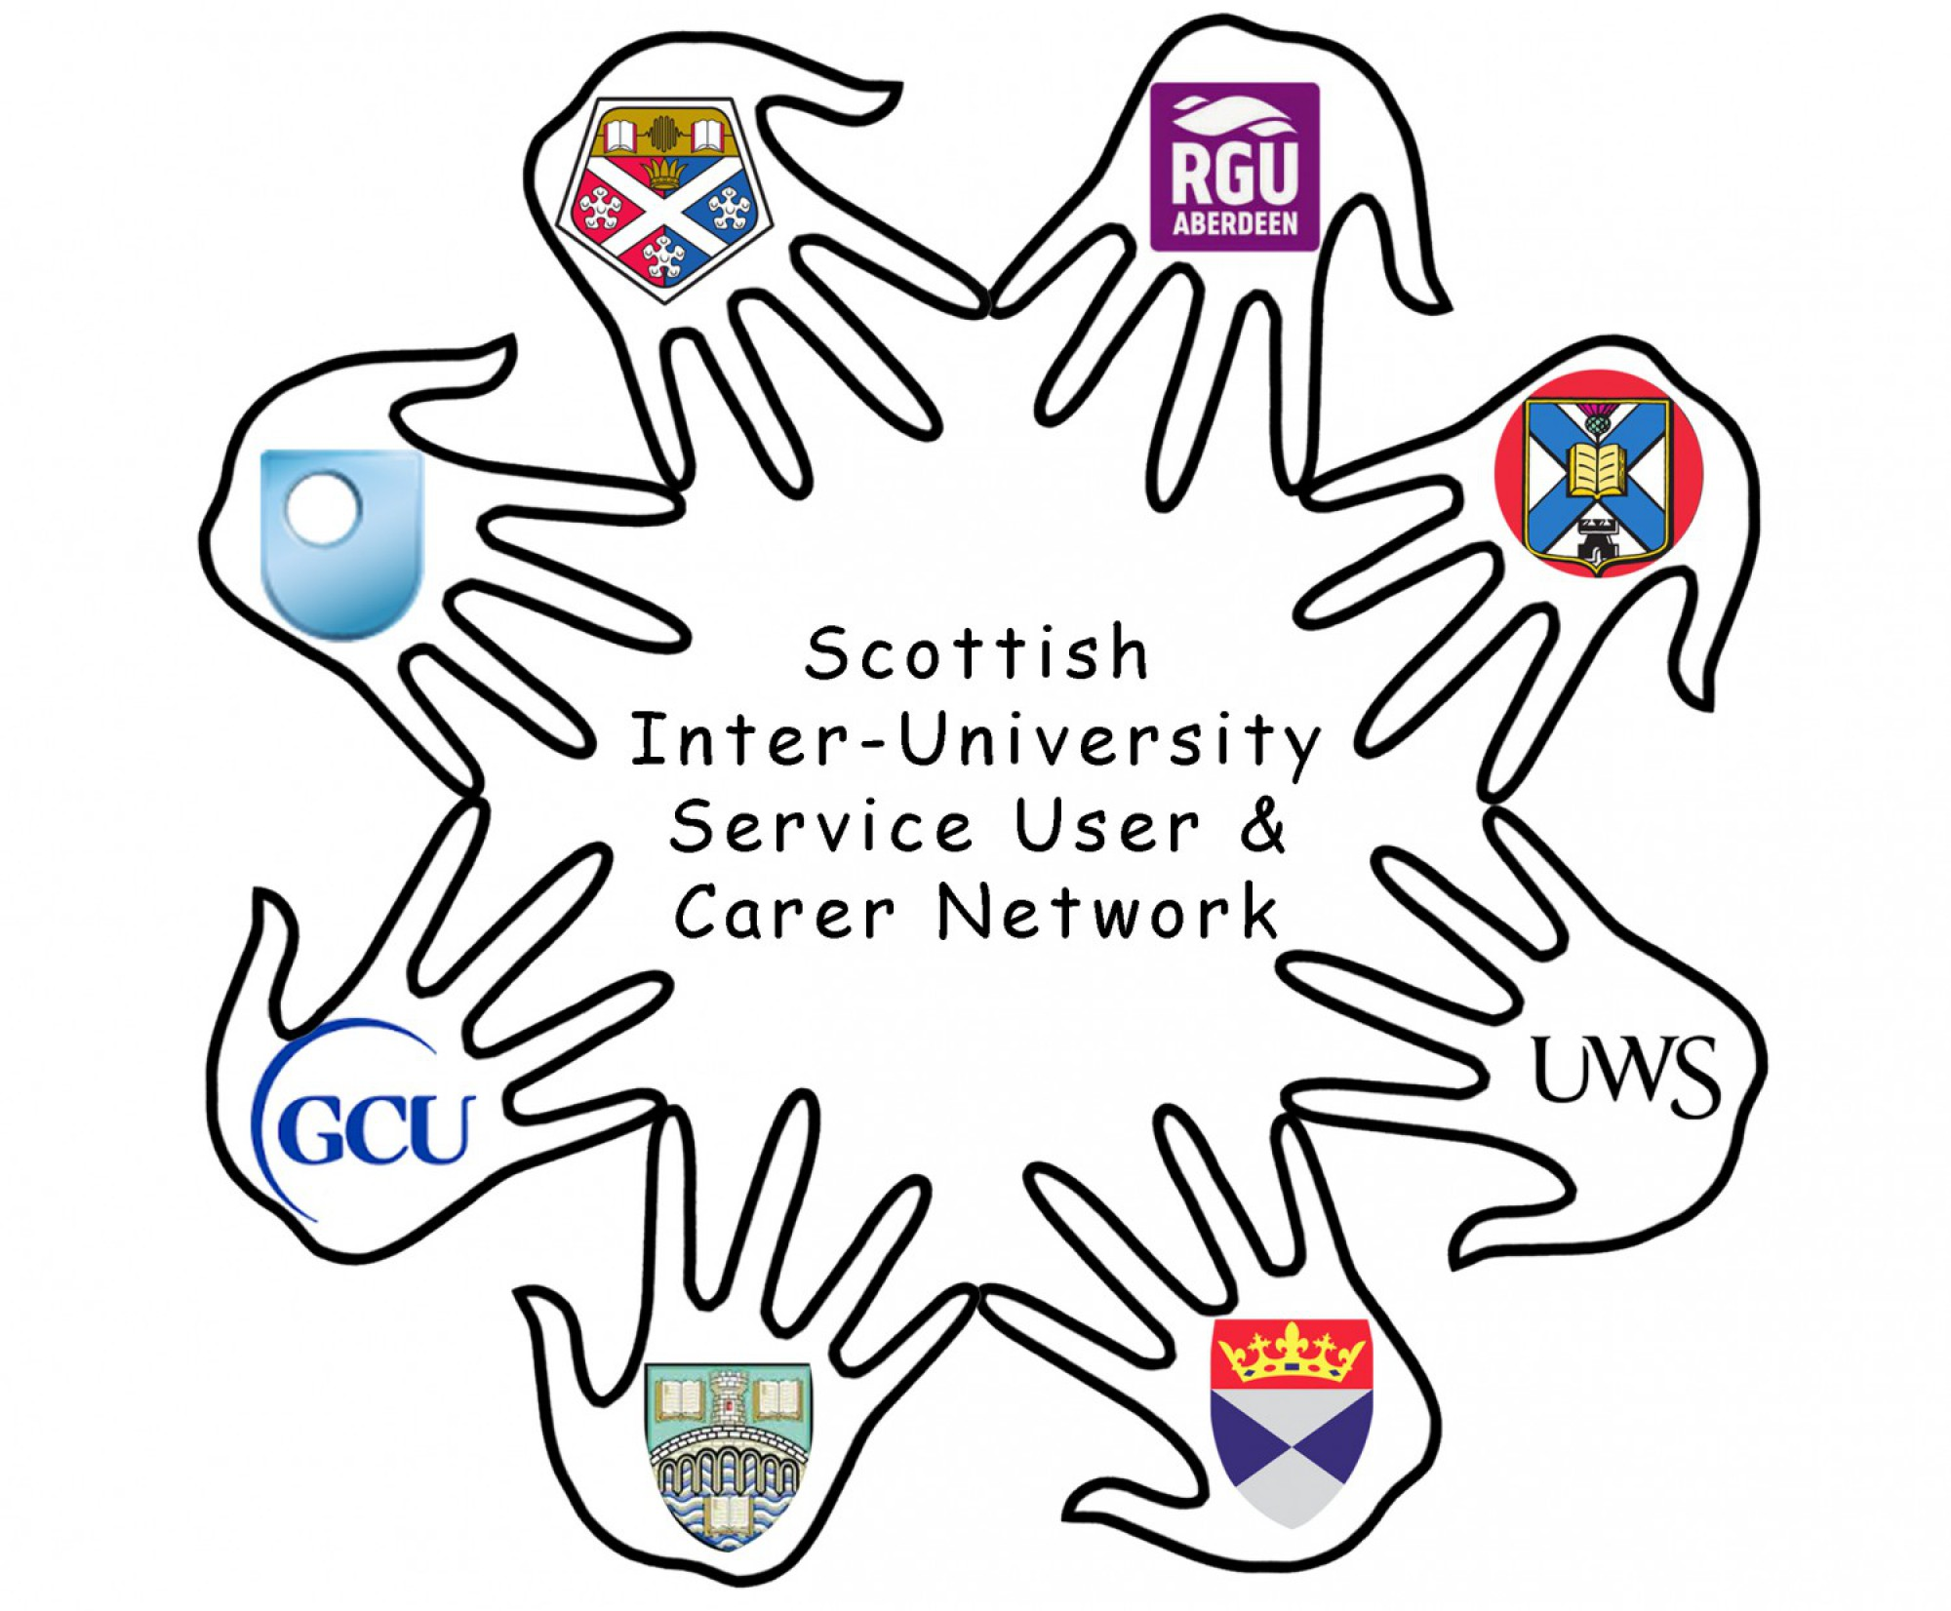
The Scottish Inter-University Social Work Service Users and Carer Network which meets three times a year and brings together representatives from the eight Universities that offer social work programmes in Scotland.

https://bettersocialwork.wordpress.com/

Review of Social Work Education
The Review of Social Work Education, Statement on progress 2015-2016, undertaken by the Scottish Social Services Council, published for consultation in November 2016. Of particular interest in this context are the principles of ‘...substantial contributions from all partners...’ and ‘... the development of a national infrastructure that is capable of enabling and sustaining a shared approach to professional learning.’ (p.3)
http://www.sssc.uk.com/about-the-sssc/multimedia-library/publications?task=document.viewdoc&id=3183

The Integration of Health and Social Care in Scotland which ‘... is about putting people and not services at the centre of our decisions.’
Health and Social Care Integration www.gov.scotland

Conference Themes, in particular:
- sharing learning points and development ideas
- participatory working in the context of austerity
- sharing learning and experience

Our discussions focused on two main questions

How can we get the resources we need to strengthen our service user and carer partnerships?
How can we get service users and carers more involved in the design and development of professional education courses?

Summary of discussions from morning and afternoon workshops
Challenges
- We need to recognise, support and protect people throughout the life span
- Burnt out social workers lose their values
- Organisational constraints are very difficult to deal with and can prevent change and new ways of doing things
- Are we talking about our own care input OR wider sharing such as in service user and carer group?
- Processes can get in the way of families’ needs
- Judgmental community responses to issues
- Bound by bureaucracy – social workers need to take innovative actions
- We need to meet the expectations of people we’re working with
- Lack of support for social work staff from organisations can be disempowering – how can we overcome this?
- Being degraded by a tutor saps a student’s confidence and stunts creativity so the student is less likely to try new things
- Collective social work views/loss of values
- Labelling issues
- Attitudes over resources

Examples of experiences
- Social work and nursing students did raised funds for this conference. Some abseiled and earned more than £800
- Staff in one service spend one day volunteering, paid for by employers
- Students, service users and carers put on an exhibition in the university to show how they worked together

Ideas and suggestions for involving service users and carers
as partners in learning
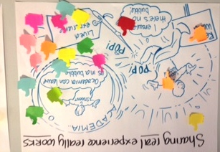
- Make sure new staff understand what SUAC involvement is about so that they become involved and committed
- Get more of an authentic voice; service users and carers can help students understand why their voices matter

- Values and attitudes are paramount and should guide everything we do at all times
- Values and professionalism must be at the forefront for students and their tutors
- Get off to a good start –you can do a lot of good right from day one
- Be aware of the effects of the environment on learning; learning should take place in different places, not only in classrooms, to help students think more creatively – open air, community venues
- Resources come in many shapes and forms – people are resources, experiences are resources (especially very difficult ones), positive attitudes are resources, learning from one another is a great resource, sharing learning is a resource
- It’s important to widen the scope of involvement so that it’s not just about always doing the same things or with the same people
- Publicise the service user and carer group to the heights to gain support for involvement
- Draw the expertise from the SUAC group and then build on this, rather than making decisions and then bringing people in
- Make sure involvement is inter-generational so that everyone can learn from one another
- Explain the skills and potential of people who are not normally listened to (more marginalised people) and find new ways of getting them involved
- Explore in more depth how to use the skills and expertise of service users and carers in different ways, for different purposes, recognising what different individuals have to offer
- Ensure that practice examples are given to high level groups and meetings
- Deal with bad attitudes immediately
- People often don’t know how to be part of a SUAC group, especially when they’re first involved, so need training and support; we need to think about how we create the SUAC groups and help them grow and develop
- Create a voice for whistle blowers
- Learn from community development and the way things are done there
- Use web based learning to help service users and carers develop their skills and build on their experience – students also learning alongside them
- Find quick and creative ways of capturing the learning – don’t let it get away – think back over what happened and what the lessons are
- Sometimes you need to break the rules to achieve something better
- Link in with other groups and places, eg, community hub for older people – share ideas and experiences
- Service users and carers – just go to workshops and make your voice heard, support other users and carers to do the same – peer support and example - service users and carers learning from other service users and carers
- Get people involved as early as possible – but often once involved there is frustration – we need a strategy with different levels of development
- Use a two pronged attack: (i) Make it normal for people to be involved in their own care (ii) Use this to shape future direction (and share this widely)
- We need to share how things work for funding applications
- Focus on how things work for the individual – what are the positives – how to share these
- Students need to be empowered to challenge issues
- We need a more balanced hierarchy within the education system

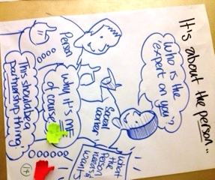
Graphics from ‘Keeping It Real’ Stirling and SSSC engagement event

