Chronologies Guidance for Pan-Lothian Partnership

Vision:

To see outcomes for children, young people and adults improve in Lothian

Aim and Purpose:

Analysing information from the past to improve the present and plan for the future for children, young people and adults in Lothian

What is a chronology?

A chronology is a written record of significant events both positive and negative, in the order they occur, in the life of the person. The chronology is regularly analysed for patterns of behaviour and for the impact which these behaviours have had on the individual’s life. This helps us to better understand the person’s needs and risks, which then informs planning and intervening for the future.

What is a Pan-Lothian chronology?

The key agencies (Health, Education, Social Work and Police) in Edinburgh, East Lothian, Midlothian and West Lothian have agreed to use the same format (the pan-Lothian template ) using a simple four column table. This means chronologies can be more easily integrated and transferred between agencies and across local authority areas.

A Chronology should be maintained

Chronologies can be used for any person and should be created when a significant event occurs for an individual. A chronology should include all relevant historical information that is known. An individual may have a chronology started from birth and maintained throughout their childhood by the universal service with which they are involved. When concerns are expressed pre-birth, a chronology would be started in the pre-birth period. When concerns are identified with a young adult, e.g. during transition planning, a chronology could be initiated at that point. Chronologies provide a key link in the chain of understanding need and risks, including the need for protection from harm.

Each service or agency will maintain their single agency chronology. If at any point there is a need for a co-ordinated approach by more than one agency, it can be helpful for the lead agency to pull all of the single agency chronologies together to get a more holistic picture. This should always be done where there is multi-agency involvement in a child or adult protection case.

Chronologies should be factual, evidence-based, relevant, up-to-date and succinct

Chronologies are not a record of every event in an individual’s life, or indeed every intervention by professionals, but only those events which are significant for the individual. Due to the weight that we give chronologies, any entry in a chronology should be based on evidence or professional assessment and not assumptions.

Chronologies should be kept up-to-date and reviewed for the ongoing relevance of previous entries. A series of entries may have been relevant at the time they were recorded, such as the various steps taken following a child protection referral, but several years later they would be unnecessarily detailed. For example, if sufficient time had passed, rather than listing the dates of an Inter-Agency Referral Discussion, joint interview, Child Protection Order and subsequent hearings as separate entries, you might just need one entry to detail the incident of abuse with one corresponding outcome, being the ultimate outcome that the child was accommodated with foster carers for three years following a Child Protection Order.

Similarly, if there had been a Duty to Inquire; an Inter-Agency Referral Discussion; Adult Protection Case Conference and potentially subsequent investigations, the record may only need to show one entry to detail the adult concern and the ultimate outcome.

Any gaps in chronologies should be cross referenced with agency records and / or explored with families as significant events may be missing. However, a gap in recording may also indicate a time when an individual’s needs were being met or protective steps were being taken by parents or wider family networks. The circumstances around these times should be explored to identify the strengths of the situation (such as the presence of a supportive grandparent or the absence of a violent partner) in order to build on this for the future.

It is important that all multi-agency and single agency versions, and any associated records within the individual participating organisations, are maintained in line with each organisation’s own records management policies and guidance.

Chronologies must be analysed for patterns to make sense of the past and the present

A well-written chronology can reveal patterns of behaviour over a period of time which may not have been otherwise apparent. It should be examined to identify the patterns and themes which are the most persistent, rather than the themes that have been the most predominant in previous reports. This analysis can help to make sense of the present, including current behaviours and reactions of individuals.

Chronologies should be used to inform assessments

Chronologies are not standalone documents but always created and updated for the purpose of assessment. When involvement with an individual is started and the need for a chronology identified, it should always be created (or where already existing, read and updated) at the earliest opportunity. It should be recognised that individual agencies may have different professional perspectives. This can include the fact that what is seen with our own eyes becomes more prominent in our thinking than what we have read about in our records. Preparing and/or analysing the chronology first, can help counteract bias by allowing us to process dry, second-hand information first. This frames how assessments are planned and approached.

Chronologies should be used and analysed in supervision

The skills of absorbing and analysing what other people have observed and heard are just as vital to any robust assessment of an individual as the skills of observing and interviewing. This can be challenging, particularly when there is a lot of historical information. Using the chronology in supervision (for social work and health staff) helps the supervisee to make better sense of the situation. A supervisee may be prompted and challenged by their supervisor to identify relevant issues such as patterns, resultant harm, strengths and protective factors.

Chronologies should be used as a working tool with families

Any chronology and its analysis are not just for professionals but for use with the individual and families as appropriate. It helps them make sense of their own history and reflect on their own or other people’s decisions and behaviours. It may also help them understand the impact on the individual of what has happened. Where appropriate, the analysis itself may even be carried out with family members or checked out with them before being used in any formal report.

Chronologies should be edited over time to summarise patterns of events and their outcomes

It is important to keep reviewing, condensing and shortening a chronology as it grows over time so that its impact will not be lost by being unwieldy. Older sections of the chronology can be summarised within the chronology itself, for example a number of similar incidents that occur over several months or years can be grouped together. This will be increasingly important for older children and young people, and adults when the finer details of each event and outcome from many years previously are probably less important than the impact of seeing many such incidents grouped together into one entry (the details of individual events will not be lost as they will always be available from earlier versions of any chronology and from agencies’ own records). In such circumstances, a chronology should usually focus on the last 1-2 years in more detail, with earlier information being summarised thematically. However, the purpose of the chronology should always be borne in mind, for example a chronology as part of a report for a Permanence Order may need to include more detail and fewer summaries.

Each agency’s chronologies should be amalgamated, edited and maintained by the lead professional to become a multi-agency chronology.

A multi-agency chronology is required usually, but not exclusively, at the point of assessing risk to an individual, for example for a Child Protection Case Conference, Children’s Hearing or Adult Protection Case Conference. However, it may also be beneficial in other multi-agency planning processes. Each agency involved, should review their own single agency chronology for relevance before sending it to the lead professional who has requested it (usually in social work). The lead professional will copy and paste all single agency chronologies into the template, before sorting it by date order, and removing any duplicate entries. All agencies will then be sent a copy of the multi-agency integrated chronology. During the lifetime of a multi-agency chronology, it will be maintained by the lead professional. Each agency will continue to add to their agency’s single agency chronology and feed in any relevant entries to the integrated multi-agency version. The relevance of any entries will be agreed at multi-agency meetings for example core group meetings following child protection registration, Adult Support and Protection Case Conferences and Review Case Conferences.

What are the headings for the chronology?

- Dates(s):
The date or date range when the event(s) significant for the individual took place. If a report is received (e.g. from the police) it is not the report which is the significant event but the incident itself, so the date should reflect when the actual event happened. A chronology can group together similar incidents by theme, with one eventual/overall identified outcome. In these circumstances the date column should show the date range covering all the similar significant events e.g. “May to November 2015; 7 incidents of domestic violence in the home; Child accommodated with grandparents”.

- Significant Event(s):
Anything that has or may have a significant positive or negative impact on the wellbeing or future development of the individual. Significant events will not be the same for each person – even within the same family. There can be no fixed list. What determines a significant event will always require professional judgment. When a chronology has been analysed, the subsequent version should, where possible, group similar events together.

- Outcome:
What happened to the individual as a result of the event. The outcome should reflect what happened to the individual not just an agency response – for example after an incident of physical abuse within the home, the outcome might be that the individual remained at home; was removed or the alleged perpetrator was asked to leave. The outcome may contain the mechanism for this (e.g. Child Protection Order obtained and child placed with foster carers, Removal Order under Adult Support and Protection and the placement of the adult). An example that is not child protection, may be that a child is displaying social and emotional difficulties and is referred to a Paediatrician. The outcome is that, following diagnosis, the child receives support from specialist services. An example of something that has a positive impact could be the reintroduction of a family member who has a protective relationship with an individual. In relation to an adult, an event may be that the adult presents with autistic behaviours and the outcome is that they agree to attend psychiatry to seek a formal diagnosis.

Where possible, we need to reflect the impact or the effect(s) of the significant event on the individual, rather than giving a long list of step-by-step agency actions in response to the event.

- Source: Name (and agency where applicable)
The original source of the information. Recognising that information may come from members of the public, family members, neighbours as well as other agencies. Information is often passed through various sources; therefore we need to get the source closest to the event affecting the individual, both for accuracy and should the fact require to be established in court. Occasionally, there may be sources of information that for reasons of safety need to remain anonymous e.g. reported by a close family member. In these circumstances anonymous can be recorded in the source column.

This is what the template looks like:
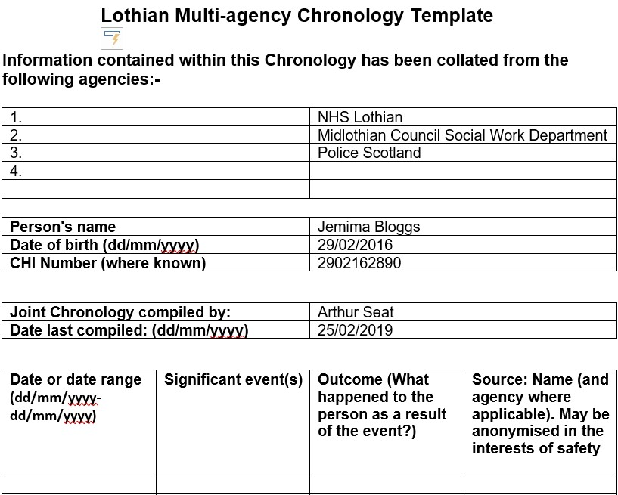

Further guidance:
Scottish Government Getting It Right Guidance on a single agency chronology:
“It should be used as an analytical tool to assist in the understanding of the impact of life events and to inform decision making.”
Care Inspectorate Practice Guide to Chronologies 2017:
“The essential purpose of the chronology is to draw together important information and assist understanding, highlighting early indicators of emerging patterns of concern”
National Risk Framework 2012:
“They are a logical, methodical and systematic means of organising, merging and helping make sense of information. They also help to highlight gaps and omitted details that require further exploration, investigation and assessment”.

