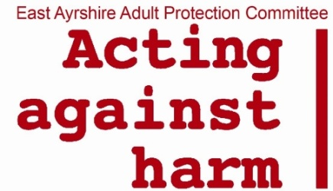

Adult Support and Protection

Role of the Second Person / Secondary Worker

Full Day Course

**AIM** Understand the role of the Second Person/ Secondary Worker within an Adult Support & Protection Investigative Interview.

**To achieve this, we will examine:**

* The role of the Second Person/ Secondary Worker before, during and after the Investigative Interview.
* The structure of the Investigative Interview.
* How the Investigative Interview supports the guiding Adult support & Protection principles.
* Common practice within Adult Support & Protection Investigative Interviews.

To Print:

To Bring:

Outline of Session

|  |  |  |
| --- | --- | --- |
| Time | Slides | Comments |
| 930 – 950  (20 mins) | 1-6 | Introduce course, and self as facilitator  Housekeeping arrangements  Ask participants to introduce themselves:   * Who they are * Where they work * What experience they have with Adult Support and Protection * What they are expecting out of today’s session   Learning agreement  Learning outcome  Agenda for today’s session |
| 950 – 1010  (20 mins) | 7- 11 | Introduction to the ASP Legislation  Overview of legislation  Principles  Definition of harm  Advocacy |
| 1010 – 1035  (25 mins) | 12 -15 | 3 Point Criteria  What can impact decision making  Unable to Safeguard   * give case study to read * ask them to identify the risk of harm * what skills means and opportunity would someone have to have to safeguard against this harm |
| 1035 – 1050 | 16 | Break – 15 mins |
| 1050 – 1110  (20 mins) | 17 – 23 | The Process  ASP Investigation  Quote from Codes of practice  Purpose of Investigation   * Ask in groups to discuss what the purpose of the investigation is * Feedback from groups   Quote from Borders Inquiry  Purpose of investigative interview |
| 1110 – 1140  (30 mins ) | 24 – 28 | Role of the second person/ secondary worker   * Exercise with three flip charts * The role of the second person/ Secondary worker * Who can be the second person/ secondary worker * What planning would you do prior to the investigative interview * Feedback as a large group with three following slides   The role  Who can it be  Planning for the investigative interview  Also consider |
| 1140 – 1210  (30 mins) |  | 5 Stage model  Introduction  Rapport  Free Narrative  Questions   * In groups write examples of the 4 different types of questions * Think about when they might be beneficial to use   Closure |
|  |  | Lunch |
|  |  | Let try it out  Read the main case studies ASP Inquiry/ AP1  In your small groups   * + Identify the types of harm   Feedback before moving onto the next questions   * + What is the purpose of the investigative interview   + How you would implement the 5 stage model   + What questions you would ask   Feedback – take a note of the questions, highlight changes that could be made to make these more effective |
| 40 mins |  | Video – 15 mins  Your Notes –  In small groups discuss:   * + What did you do well   + What did you struggle with   + What would you do differently   + What actions would you now take |
| 20 mins |  | After the Interview – process  After the Investigative Interview  Protection Orders |
| 20 mins |  | Learning Outcomes  Thank you – conclusion   * Invite for any questions * Their future learning needs * Ask to complete the feedback form |