As One We Survive - Matthew’s story
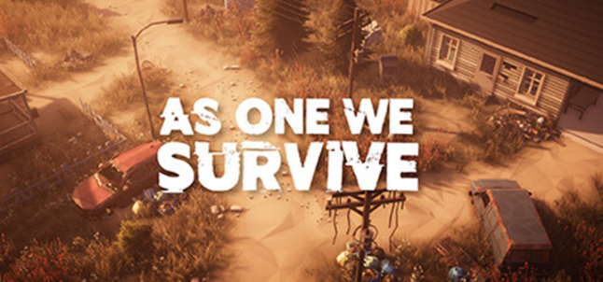
Can you tell me a little bit about your background and how you came to be involved in PAN?
At the age of 6, I went to live with a foster mother, me and my brother. We got separated from my older three brothers. So, me and my little brother went to live in a foster care home at the age of 6, and I stayed there until I was 21. And my little brother is still living there now, to this very day. I took her last name. So she is my mum. My real mum had really bad mental health problems.

She had really bad schizophrenia. For her to calm down, she used to lock me in wardrobes and into cupboards, just for a couple of hours just for her to chill. I know that's not right, but I was only two at the time. I'm still involved with social services to this day, as a parent. I got 3 kids. My oldest is 5 and my youngest is 1.

And we are involved in social services right now. I got involved in PAN because of adult Jigso. I had a support worker, a dads’ worker from Jigso that gave me confidence to go out because I was isolated in the house from a young age, all the way up to now. I didn't really have many friends. And anyway, my friends, weren't really my friends, if you know what I mean. They were using me I think as the class clown.

I was the one they used - to make them entertainment, not myself, it was just to fit in, because I was so isolated. I got involved with class B drugs, smoking cannabis, and then went on to harder drugs, like sniffing cocaine or things like that. And then I got involved with SYSHP, it’s a homeless project. They took me in their wing and gave me the tools to go and live independently. I came into PAN then, about six months ago.

Thinking back over the last 12 months – what good or bad changes have come about as a result of your involvement with PAN?

At the start, I was a bit shaken working with social workers because of my past experiences, going through so many social workers. Probably I'd been through about 15 different social workers, getting bonded with the individuals. Then they bugger off about 3 or 4 months down the line. So, I was a bit scared of bonding with social workers and other professionals just because they might judge me, who I am, and things like that.

From about 3 months into it, I gained their trust. I gained other people's trust, with some friends, and now they are my family as well. I didn't really have a father figure in my life. My dad died when I was 6. My foster dad died, and my real dad I never knew. So having dads in the group has made me more confident. It’s made me believe that dads do need help as well.

Of all the changes you have identified, which one is the most significant to you and why?

Sharing stories. I think sharing with the dads that are in a group now. It lets me listen to their stories and they listen to my stories and some of them are probably similar. We do struggle as dads. We don't like to speak out. We don't like to express our feelings. We don't like to be weak.

We are the bread of the family. We want to go out working, we want to look after our children, but sometimes we do struggle, like women do as well. So sharing stories has been the most significant - and connections and confidence that I can actually speak with my experiences. There's no judgment at all. Everyone is equal. Confidence is the most significant with me, probably as with most people, confidence building and speaking. I do struggle with my speech and language. I do struggle to express my feelings. Some people might take it the wrong way, some people might take it the right way, but that's who I am, and I won't change it for the world. I'm a confident person.

Regarding the most significant change you have chosen, the confidence, please can you tell us a bit more about what it was like before?

I feel like I was locked in a room. I never used to go out. When I first had my first child 5 years ago, I didn't like to speak to anyone. It was just me and my girlfriend, and I was trying to be like the best dad I can be. I didn't want anyone influencing in my parenting because I think what I was doing is being the best I can be.

What it is like now

Now I know now I've got more confidence. I've got 2 other children that thank God, that thankfully, social services has let be in my care.

What was it you think brought about the change?

Self-esteem. It’s given me motivation really, to come to PAN meetings, to come to PAN fun days, meeting all the boys here, and the girls obviously. Everyone welcomes me and there's there's no judgment. I know I’ve only been here for about six months, but it's probably been the best six months I’ve had since about two years ago. And I can bring my skills and knowledge as well because I have done a social work course before I came to PAN. Plus I've been through the system myself, so hopefully I can bring the skills and experience to the group.

