Most Significant Change (MSC)
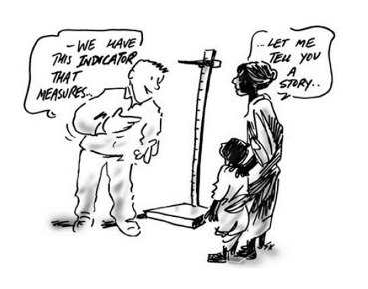
What is MSC?
MSC is a participatory, learning-focused approach to monitoring and evaluation that was developed by Rick Davies and Jess Dart in the 1990s. It is focused on storytelling and dialogue-learning, and was developed in the context of evaluating complex public health and international development projects, in which prediction can be difficult and control is often limited. It provides rich qualitative data to complement metrics.
MSC follows a 3-stage cycle of gathering stories, learning from the stories and feeding back what’s been learnt and what needs to be done.
Story gathering
Stories are gathered from the frontline about what has changed as a result of an action or project. The stories follow a particular structure, which focuses on what the person thinks is the most significant change and why, and how it came about.
Learning from the stories
A selection of MSC stories are then shared and discussed in story selection panels, which are made up of key stakeholders and strategic decision-makers. The aim of these panels is twofold – the learn from the stories and to build relationships and mutual understanding between members of the panel regarding what they believe to be most significant in the stories
Feedback what has been learnt and what needs to be done
The learning from the story selection panel discussion is fed back to all stakeholders in a summary report, along with the implications and recommendations for action.
What are the benefits of using MSC?
As well as gathering rich qualitative data, the method also supports the development of relationships and mutual respect amongst stakeholders and supports the alignment of everyone involved around what truly matters in a project or service and what needs to be done.

