

Aberdeen City Health and Social Care Partnership

Practice Guide to Chronologies in Adult Social Work Services

Version Control
Date Approved by…..
Date of Review:

Contents

 |  | Page No
1 | Introduction
2 | Definition and Purpose of a Chronology
3 | The Role of Chronologies in Practice
4 | Principles of Good Chronology Practice
5 | Types of Chronologies
6 | What a Good Chronology looks like
7 | When to begin a Chronology
8 | Evidence Based Practice and Decision Making
9 | Inputting a Chronology onto D365
10 | Information Sharing
11 | Learning and Development
12 | Supervision and Peer Support
13 | Monitoring and Improvement
Appendices
A | Chronology Template
B | Examples of Significant Events
C | D365 Guidance
D | Links to National and Local Guidance

1. Introduction
Chronologies are a tool used in all areas of social work practice. They provide a structured, sequenced record of significant events in an individual’s life, enabling practitioners to identify patterns, assess risk, and make informed decisions that promote safety and wellbeing.
This guidance has been developed to support practitioners across adult social work services in Aberdeen to use chronologies confidently and consistently. It reflects national expectations, local learning, and reflects the principles of trauma-informed practice. Chronologies are often viewed as administrative tasks, or an ‘add on’ to casework, but used effectively they are a tool to help us understand an adult's lived experience, support our decision-making, and help us to improve outcomes for adults who use our services.
Whilst chronologies are often thought of in the context of Adult Support and Protection, chronologies should be a tool used in all areas of social work practice and this guidance will help you to:
- Understand the purpose and value of chronologies;
- Apply core principles to your recording practice;
- Use chronologies to support assessment, planning, and review;
- Reflect on your own practice.
Chronologies are most effective when they are embedded in everyday practice as part of our assessment and help us to understand both risk and resilience. In keeping with the principles of Trauma Informed Practice, chronologies are a tool that can be developed alongside the adult.
Improving chronology practice has been a priority across adult social work services both nationally and locally for several years and while chronologies are already widely used by our colleagues in Children’s Services, the development of chronology practice within adult services has been limited to certain service areas and in particular adult support and protection.
In developing this guidance, we have been supported by Iriss, using the tool Leading Chronology Improvement: Reflection and self-assessment tool.

2. Definition and Purpose
There are many definitions of what a chronology is and isn’t, but for the purposes of this guidance we have referred to the definition in the Care Inspectorate’s Practice guide to chronologies . This definition is taken from the National Risk Framework and although written for children’s social work equally applies across all service areas.
“Chronologies provide a key link in the chain of understanding needs/risks, including the need for protection from harm. Setting out key events in sequential date order, they give a summary timeline of child and family circumstances [or those of an individual using adult services], patterns of behaviour and trends in lifestyle that may greatly assist any assessment and analysis. They are a logical, methodical and systematic means of organising, merging and helping make sense of information. They also help to highlight gaps and omitted details that require further exploration, investigation and assessment”.
The National Framework to Support the Assessment of Children and Young People 2012

The definition in the national framework although written from the perspective of those working with young people, the key parts of this definition are as applicable across adult services. Further on in the guidance we will look in more detail about the different types of chronologies and their use, but chronologies can be used on a single or multi agency basis and can assist in current and ongoing assessment and risk management, or as a timeline to review past events. Chronologies can apply in different circumstances but essentially the basic approach is the same.

3. The Role of Chronologies in Practice
Chronologies are more than a record of events—they are a professional tool that supports critical thinking, risk assessment, and decision-making, helping practitioners and multi-agency partners to:
- Understand the adult’s journey: Chronologies provide a structured overview of significant life events, helping to build a picture of the adult’s lived experience over time.
- Identify patterns and triggers: By mapping events chronologically, practitioners can spot recurring themes, escalating concerns, or protective factors that may otherwise be missed.
- Support early intervention and prevention: Chronologies can highlight cumulative risk and inform timely responses before harm occurs.
- Enhance multi-agency collaboration: When shared appropriately, chronologies support a shared understanding of risk and need across services.
- Inform assessment and planning: Chronologies underpin robust assessments and contribute to more effective support and protection planning.
Chronologies are particularly important in Adult Support and Protection (ASP) work, where understanding the context and history of harm is essential. However, chronologies should be used routinely across adult services to support practitioners in their assessment and decision-making.
A good chronology is not a list of every contact or task—it is a record of significant events that have an impact on the adult’s wellbeing or safety. They should be concise, relevant, and regularly updated, with the adult’s voice and perspective reflected wherever possible.
The article Why writing a chronology should be the first thing you do in an assessment gives insights into the importance of chronologies as part of our assessments.

4. Principles of Good Chronology Practice

The following principles should guide all practitioners when creating and maintaining chronologies:
Purposeful – chronologies should serve a clear function – supporting assessment, identifying risk, and informing planning. Each entry should contribute meaningfully to the overall understanding of the adults situation
Person-centred and Trauma-Informed - chronologies must reflect the adult’s voice, experiences, and perspective. They should be written with sensitivity, avoiding language that is judgemental or clinical. Practitioners should consider how the adult might feel reading their own chronology
Significant, Not Exhaustive - chronologies are not case notes/observations. They should focus on significant events that impact the adult’s wellbeing, safety or circumstances. This includes changes in health, relationships, housing, finances, or service improvement

Analytical – Chronologies should support critical thinking. Practitioners should use them to identify patterns, triggers, and protective factors – not just record events. Where appropriate, brief analysis or reflection can be included
Timely and Accurate – Entries should be recorded as close to the event as possible, using clear, factual language. Dates, sources, and outcomes should be included to ensure accuracy and accountability
Shared and Multi-Agency Where Appropriate - In complex cases, especially those involving ASP, multi-agency chronologies can provide a fuller picture. Practitioners should contribute to and draw from shared chronologies where information sharing protocol allow

Evolving – Chronologies should be regularly updated and reviewed. They are not static documents but living tools that evolve with the adult’s circumstances and support journey

A good chronology is highlighted in the practitioner reflection below which was taken from the IRISS

“One interviewee noted the role chronologies could play as a tool to support a meaningful conversation with supported people about their lives and the events which impacted them… A chronology was recognised as a learning and reflection tool for both the supported person and practitioner… respondents commented it could be used as a therapeutic tool, a point also made in the interview with learning and development colleagues and aligned with a trauma-informed approach.” (Iriss, 2023)

The Quality framework for Adult Support and Protection outlines that a very good chronology demonstrates an understanding of the person’s trauma and the impact of it on their life.

5. Types of Chronologies
Chronologies can take different forms depending on the context, purpose, and level of agency involvement. Understanding the types of chronologies and when to use them is key to effective practice.

Single-Agency Chronologies
These are developed and maintained by one service or professional (usually Social Work) and focus on events known to that agency.
Use when:
- The adult is not subject to multi-agency processes.
- You are building a chronology as part of routine assessment or care planning.
- You are contributing to a wider chronology from your agency’s perspective.
As a minimum all cases involved open to adult social work services, whether ASP or not, should have a single agency chronology.
Practice example
William, aged 84, lives alone in a privately owned flat. He has a history of falls, a diagnosis of dementia, and increasing difficulty managing daily tasks. Concerns were raised by his GP and Community Nurse regarding self-neglect, poor nutrition, and social isolation.
The Care Management Team maintained a single agency chronology to track significant events and concerns so they were able to use the chronology to support the decisions made regarding William’s future care needs in a timely manner. The chronology was also used as a tool to facilitate multi-agency input and inform care planning. Through a clear timeline of events and the early completion of a chronology, the Care Manager was able to see when concerns were escalating and start discussions with Willian about his future care needs in a timely manner. William was able to be part of that discussion rather than waiting for the situation to reach crisis point.

Multi-Agency Chronologies

Multi-Agency Chronologies bring together significant events from multiple services into a single, shared record. They provide a fuller picture of the adult’s circumstances and are especially useful in complex or high-risk cases. This would include entries from social work, health, housing and police etc
Use when:
- The adult is subject to multi-agency planning, for example ASP processes.
- There is a need to understand cumulative risk across services.
- Agencies are working together to assess or manage risk.
At present we do not have a process in place for developing multi-agency chronologies, but chronologies should be discussed as part of ASP Case Conferences which would allow for multi-agency discussion and input into chronologies.

Practice Example
Mr D is an older adult with a history of mental health illness, alcohol misuse, and high-risk behaviours including wandering in remote areas. He lives in sheltered housing and is known to multiple services including Social Work, GP, Police Scotland, and Acute Hospital Services.
The multi-agency chronology that was compiled for an Adult Support and Protection Case Conference allowed professionals to identify the cumulative risk across health, social care and police, and highlighted patterns of behaviour such as periods of alcohol misuse when under stress which lead to instances of wandering. The information in the chronology supported those working with Mr D to support him in a timely manner and co-ordinate interventions, it also supported and informed the decision that Mr D could be removed from adult protection as the multi-agency chronology enabled a shared understanding of risk and informed the decision to continue support while removing the need for Adult Support and Protection measures.

Thematic or Issue-Specific Chronologies
This type of chronology focuses on a particular area of concern (e.g. financial harm, mental health episodes) and can be used to support focused assessments or reviews.
Use when:
- A specific issue needs to be explored in depth.
- You are preparing for a case conference or review.
- You are analysing patterns related to a particular risk or need. As a recommendation from an Adult Support and Protection Learning Review Sub Group, or a Quality Assurance processes. The chronology function on D365 allows practitioners to select chronology entries, supporting practitioners to pull out specific themes (e.g. in relation to financial harm, ASP concern reports)

Chronologies for Case Transfers or Reviews
These summarise key events to support transitions between workers or services, or to inform formal reviews.
Use when:
- A case is being transferred to another team or agency.
- You are preparing for a significant review (e.g. large-scale investigation, Learning Reviews).
- You need to provide a concise overview of the adult’s journey

Ms M is a 40 year old woman who has been known to both children and adult social work services. Ms M has recently moved from one local authority to another and as part of the case transfer notes the transferring Social Worker provided an up-to-date chronology. This chronology provided detail on significant life events, relationship and employment history, child protection and adult protection concern reports, and information on significant health diagnoses.
Through this information the allocated Social Worker was able to see the history of trauma and gain an understanding of risk in a chronological order to inform planning of services going forward. It also meant that an assessment could be carried out based on current needs without the need for Ms M to go back through some difficult parts of her past and relive previous trauma.
Using a chronology in this way can support working in a person-centred way.

6. What a good chronology looks like
To ensure chronologies are effective, consistent, and meaningful across adult protection and wider social work practice, it is essential to uphold clear standards. These expectations apply to all practitioners contributing to or using chronologies, regardless of role or agency.

Clear and Concise
Entries are brief but informative, avoiding unnecessary detail or jargon
Factual and Accurate
Events are recorded objectively, with dates, sources, and outcomes clearly stated
Relevant
Only significant events that impact the adult’s wellbeing, safety, or circumstances are included

Analytical
Where appropriate, entries include brief reflections or highlight patterns and concerns
Person-centred
The adult’s voice, views, and experiences are reflected, and language is respectful and trauma-informed
Up-to-Date
Chronologies are maintained regularly and reviewed at key points (e.g. ASP Case Conferences, transitions)

7. When to begin a Chronology?
Practitioners often ask when they should start a chronology? Practitioners should be thinking ‘chronology first’ during any interaction with an adult. Chronologies can be started when beginning to work with the adult to help identify emerging concerns, or after a significant event has already occurred to help professionals understand why it happened. We are continually assessing and reviewing in Social Work, and with that we will gain information that is relevant to include in a chronology. Starting to think about recording information gained during an assessment in a chronological order will support your assessment and recommendations further.
Practice Example
A Justice Social Worker who is gathering information as part of a Justice Social Work Report tries to find chronology information in Social Work Records but finds that there is no information. To assist them to understand the adult better they decide to use the chronology template to record the significant information that they have managed to gather through interviews for the Justice Social Work Report.
Although starting a chronology can be time consuming work, the Social Worker found that it informed that through doing this it informed the risk assessment and also gave a greater understanding of trauma in the adult’s life and how that impacted on their ability to engage with professionals. Rather than assuming this information, the Social Worker could see this written out in a format which was easy to understand. This supported the Social Worker in deciding what the most appropriate court disposal would be and also to support the adult to engage with his Community Payback Order.

8. Evidence Based Practice and Decision Making
Chronologies should be used to evidence decision making, they allow for practitioners to identify patterns and risks for adults which in turn focuses on protective factors and risk management for the future. Chronologies should be discussed and shared as part of an Adult Protection Case Conference and as part of risk management and protection planning.

9. Inputting a Chronology into D365
The chronology sits alongside the contact screen to reflect that the chronology should be considered as part of the suite of assessment tools and not case specific. Each chronology item should be added individually, although there can be instances where it may be appropriate to group significant events together. An example of this may be multiple reports about the same significant event.
The different stages of inputting a chronology into D365 can be found below to support you in terms of content under each section.

Details Section
Chronology Type | There are 3 options to pick from here. You can select from :  - Life Event  - Communication/Contact with Service  - Planning/Decisions Making
Chronology Sub Type | This gives more context depending on the option chosen
Client Type | This is not a pre-populated field and you should always select client in the drop down menu
Client | You will need to search for the name of the client the chronology entry is for. This will populate the date of birth section for you
Age at Date of Event | This will populate when the date of event is added and saved
Date of Event | The date of event is mandatory. If you do not have a specific event then you should use the first of the month
End of Event Date | This can be the same date as the event unless you are recording a series of events
Significant Event | In this section you should include a brief description of the significant concern, event of incident. Information should be clear; factual; accurate; current; evidence based; succinct and concise to support good decision making. A significant event may include:  - Significant changes in an adults health or wellbeing (this may include a stay in hospital, a change in care needs etc)  - Significant changes in family, relationship or carers circumstances  - Adult Protection Concerns, or any investigations or interventions under Adult Support and Protection  - Welfare concerns  - Legal Powers (Power of Attorney details, welfare of financial guardianship, interventions under the mental health act  - Events including missed appointments with services, involvement in offending behaviour, associations with people who may present a risk of the adult, use of substances, traumatic experiences
Address | This is optional.

Source Section

Source of Information | From the drop-down menu pick the source of information (if you need to provide further details then you can add this under source details)
Source Social Worker (User) | Enter your own details here
Source Details | Information may come from a variety of sources. It could be a professional service, agency, family member of neighbour. It may also be self-report. This section allows you to provide further detail on where the referral has come from
Impact and Outcome Section
Impact | Impact is either positive, neutral or negative and below that more context and crucially, professional analysis is required. Practitioners should provide evidence of the impact on the adult. It can often be difficult to define whether an event is entirely positive or negative as this can be subjective i.e. the event itself could have been negative but the impact could be positive , or the adult themselves may interpret an event as negative or positive. Unless you are clear on whether an event is positive or negative then select neutral. The important detail in this section is the detail of the impact.
Impact Details | In this section you can include specific information on the impact of the significant event. Completing this section first may help you determine whether the event is positive or negative
Action Taken | Record here the actions take to reduce the impact/mitigate the risk

Other Details Section

Entered by | This field will self-populate
Entered date | Date of entry to chronology
For guidance on Producing a Chronology Document please refer to Appendix C.

- Information Sharing

It is important that practitioners understand when to share information; what information to share; how much information to share; who to share the information with and the way in which the information should be shared. This equally applies to chronologies so it is important we recognise that practitioners understand the legislation underpinning information sharing which includes:
- The General Data Protection Regulation (GDPR);
- The Data Protection Act 2018;
- The Human Rights Act 1998, and the
- European Convention on Human Rights (ECHR).
Legislation supports lawful information sharing and should not be seen as a barrier.
GDPR is a legal framework that sets out guidelines for the collection and processing (sharing) of personal data (information) and special category data (information) of individuals within the European Union (EU). GDPR describes the principles which must underpin information sharing practice and the basis (formerly known as conditions) upon which information can be shared. All practitioners must understand the principles and basis for sharing information and this equally applies to chronologies.
As part of everyday social work practice practitioner’s have access to a variety of records, including health records, it is important to be mindful of then taking that information and using it within a chronology. Additionally, there may be closed Police information that is shared that is significant but it would not be lawful to use as part of the chronology. It also may be the case that the adult has shared something significant with you which has impacted on them but they would not want specific details of this included in their chronology.

11. Learning and Development
Chronologies are a core professional skill in social work. Chronologies require practitioners to use a range of skills such as critical thinking and reflective practice, alongside professional curiosity and good assessment skills to assess need and risk. This section outlines how practitioners can build and sustain these skills.
Chronology practice should be introduced early in a practitioner’s development. This includes:
- Understanding the purpose and value of chronologies.
- Learning how to identify and record significant events.
- Using templates and digital systems (e.g. D365) confidently.
- Exploring real-life examples and case studies.
Training
Chronology skills e-Learning Module
All new practitioners are required to complete the e-learning module available on ACC Learn as part of their induction.
Developing Chronology Practice
This is mandatory training for all qualified social work staff and is delivered twice yearly and as part of the Adult Social Work Service Core Skills Programme.
Embedding Chronologies in Practice
This training is primarily aimed at Senior Social Workers or those with management responsibilities to support practitioners to embed chronologies in everyday practice.
- Supervision and Peer Support
Chronology development should be supported through:
- Regular supervision that includes review of chronologies.
- Opportunities to reflect on what is being recorded and why.
- Council Officer Support Groups or practice development sessions to share challenges and good practice.
Line Managers should support practitioners through supervision to use chronologies as tools for thinking—not just recording. As a minimum, one chronology should be considered and discussed at supervision using the following questions as a guide for reflection.

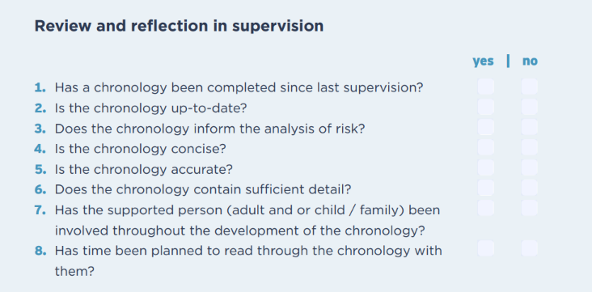
(Iriss, 2025)

Examples of Reflective Questions
The following questions can be used as a reflective prompt in peer discussion, supervision, team discussion or when a practitioners want’s to analyse the information in the chronology:
- What patterns or themes are emerging in this chronology?
- Are we capturing the adult’s voice and perspective?
- What might be missing or under-represented?
- How is this chronology informing our assessment or planning?

What patterns or themes are emerging in this chronology?
- Are we capturing the adult’s voice and perspective?
- What might be missing or under-represented?
- How is this chronology informing our assessment or planning?

Practitioners and Line Managers may find it helpful to refer to The Quality Improvement Framework for Adult Support and Protection. Section 5.2 of the framework (p29-30) gives examples of ‘what very good looks like’ and ‘what weak looks like’ to allow practitioners to reflect on the quality of chronologies.
These key questions in the The Quality Improvement Framework for Adult Support and Protection can also be used in Supervision:
- Is there a updated chronology?
- Does the chronology focus on significant life events and the implications of these on risk?
- Any comments? Particularly if no, please state why it is not an acceptable standard
- Is there evidence of multi-agency input into the chronology?
- Was the chronology used to inform decision making?
- Do you think anything was missing?
- What was missing from the chronology?
- How would you rate the quality of the chronology
- Why did you provide this rating?

- Monitoring and Improvement

Quality Assurance
Chronology practice should not be static—it must evolve through continuous reflection, feedback, and quality assurance. Monitoring how chronologies are used and supporting practitioners to improve them is essential to ensuring they remain meaningful, person-centred, and effective.
The Quality Improvement Framework for Adult Support and Protection is a tool that the joint inspection team will use for future inspection activity and for adult protection partnerships to carry out multi-agency self-evaluation of their local adult support and protection arrangements. This is also used in self-evaluation activities which are critical to drive continuous improvement for adult support and protection. Indicator 5.2 Chronologies outlines what “very good” and “weak” chronology practices looks like. Although this has specific reference to Adult Support and Protection what “very good” and “weak” looks like is a good guide to overall chronology practice.

Tools for Self-Assessment
Practitioners and teams can use tools such as:
- The IRISS Chronology Reflection Tool – to assess the quality and purpose of chronologies. This tool can be used at service or team level to improve chronology practice.
- The The Aberdeen City Adult Support and Protection Procedure and Guidance for Quality Assurance and Improvement 2025 – to support structured review and improvement.
- Service specific QA Tools
These tools can be used individually, in supervision, or in team meetings.

Appendices
The appendices provide practical tools, templates, and reference materials to support the application of this guidance in day-to-day practice. These resources are intended to be used flexibly and adapted to suit the needs of individual adults, teams, and services.

Appendix A: Chronology Template

Name | Click or tap here to enter text. | Date of Birth

Date of Event | Age at event | Significant Event | Source | Impact Details (either positive, neutral or negative | Action Taken/  Outcome | Recorded By
The date the significant concern, incident or event occurred should be recorded in this box. If you do not know the date please put down the 1st of the month | D365 will calculate this automatically | A brief description of the significant concern, event or incident should be recorded here. When you are entering information write as though the adult is reading the entry. Language should be in plain English and non-judgemental. Information should be clear; factual; accurate; current; evidenced-based; succinct; and concise to support good decision-making  For examples of significant events please refer to Appendix B | The source of the significant event should be recorded here. i.e. who and what practitioner, service or agency was the source of the information | The impact on the adult may become clearer over time and may also change  **remember that a positive impact will evidence resilience | Record the professional action or response taken to mitigate the impact/risk to the adult.  If no action taken is taken the practitioner should specify why not | Enter your details here

Appendix B: Examples of Significant Events (please note this list is not exhaustive)
Health and Wellbeing | Diagnosis of a serious or long-term condition  Hospital admissions or discharges  Mental health crises or interventions  Substance use concerns or treatment episodes  Changes in medication that impact functioning
Adult Support and Protection (ASP) | ASP Referrals or inquiries  Case Conferences and review outcomes  Implementation or closure of protection plans  Notable disclosures of harm or risk  Police Concern Reports (Welfare Report)  Date protection orders were granted or revoked
Living Situation | Moves between care settings or change in housing situation, address etc  Evictions, homelessness, or housing insecurity  Environmental concerns (e.g. hoarding, fire risk

Relationships and Social Networks | Changes in family or carer arrangements  Bereavement or loss of key relationships  Reports of domestic abuse or coercive control
Service Involvement | Start and end of formal support services  Missed appointments or disengagement from services  Multi-agency meetings or significant professional concerns
Legal and Financial | Guardianship or Power of Attorney granted or revoked  Financial exploitation or concerns raised  Criminal justice involvement (e.g. charges, convictions)
Adult’s own views and Experiences | Expression of fear, distress, or feeling safe  Requests for help or support  Changes in capacity or consent

Appendix C
Producing a Chronology Document
The principle means of producing the chronology document, having selected the items required, is not currently working (as of August 2024). This will be resolved and users notified.
However, another means, using Power BI which is another linked Microsoft Product is available to all users.
Chronology - Power BI
It opens up this screen into which the user would enter the Contact or Organisations ID (not a case ID) then press ‘view report’.
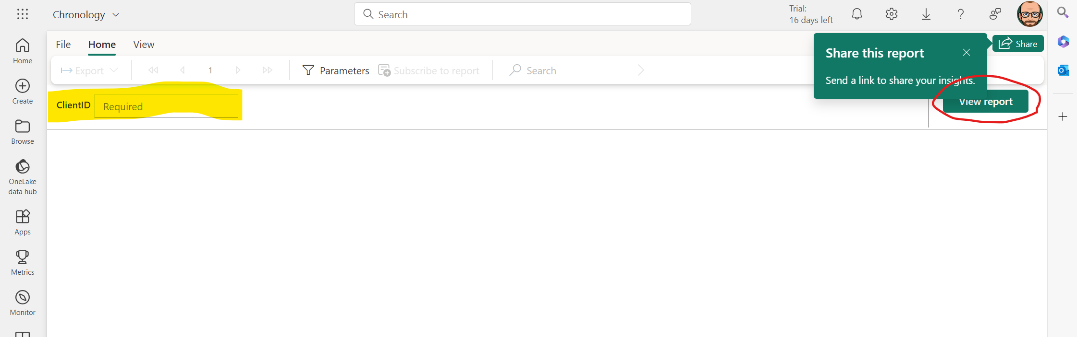
The Chronology Items then appear in the blank section.
In order to produce a saveable and sharable version of the report do not use the Share this report button, in green above.
Instead select export then PDF as highlighted below.
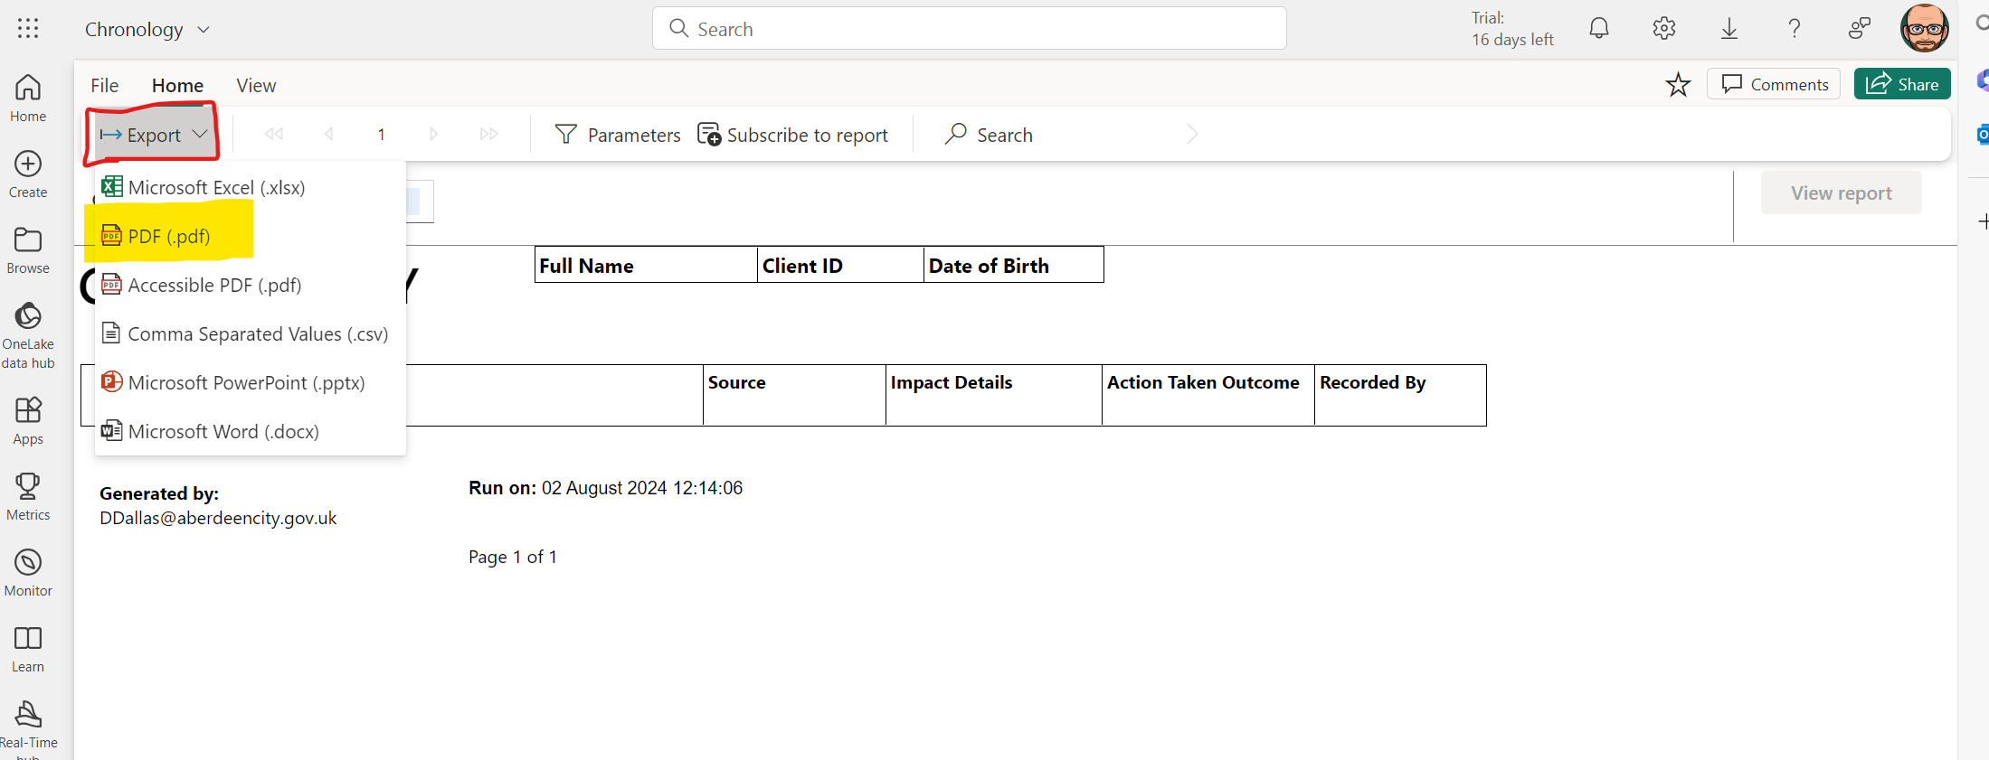
The file should then be saved in the ‘Chronology Items’ Folder against the contact or organisation. (n.b. – this is where Chronology items would save automatically when full in system functionality is restored)

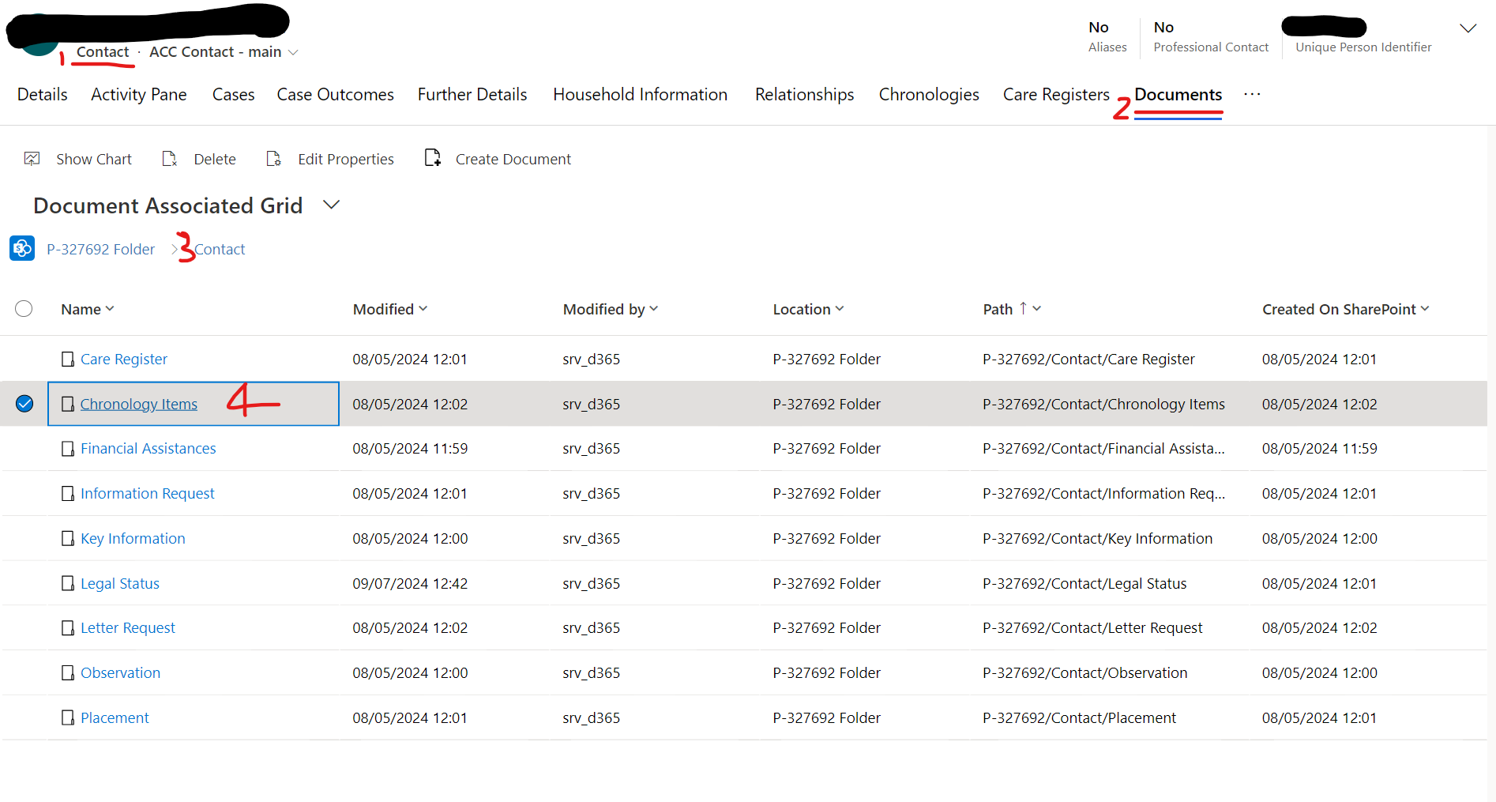

Appendix D: Links to National and Local Guidance
- Scottish Government: Adult Support and Protection Code of Practice
Adult Support and Protection (Scotland) Act 2007: Code of Practice - gov.scot
- IRISS: Chronologies Reflection Tool
Leading chronology improvement: Reflection and self-assessment tool | Iriss
- Quality Improvement Framework for Adult Support and Protection
Quality framework for ASP September 2024.pdf
- Care Inspectorate – Practice Guide to Chronologies
Practice guide to chronologies 2017.pdf
- D365 Guidance
D365 Chronologies Guide - Adults.docx

- Community Care Article ‘why a chronology should be the first thing you do in an assessment’
Why writing a chronology should be the first thing you do in an assessment
- IRISS – Chronologies in Adult Support and Protection: Moving from current to best
Chronologies in Adult Support and Protection: moving from current to best | Iriss
- Completing Social Work Chronologies – Practice Tool (2022)
Completing social work chronologies: Practice Tool (2022) | Research in Practice

